Experiment 10 :5G Network Slicing Environment Using MATLAB
Aim
To analyze the performance of a 5G Network Slicing environment by studying the number of
network slices, slice utilization, and end-to-end latency using MATLAB.
Objectives
Objective – 1: Analyze the Number of Network Slices
Analyze the creation and allocation of multiple network slices in a 5G network using MATLAB.
Observe how different slices can be configured to support diverse service requirements and
applications.
Objective – 2: Compare Slice Utilization (%)
Compare the utilization of different network slices using MATLAB. Analyze how efficiently
network resources are allocated and utilized across multiple slices.
Objective – 3: Analyze End-to-End Latency (ms)
Analyze the end-to-end latency of different network slices using MATLAB. Compare the latency
values to understand the Quality of Service (QoS) requirements of various 5G applications.
Software Required
• MATLAB
Theory
Network slicing is a key feature of 5G that enables a single physical network infrastructure to be
partitioned into multiple logical networks called slices. Each slice is optimized for a specific
service category, such as enhanced Mobile Broadband (eMBB), Ultra-Reliable Low-Latency
Communications (URLLC), or massive Machine-Type Communications (mMTC). By
dynamically allocating network resources, network slicing improves flexibility, resource
utilization, and Quality of Service (QoS) while supporting diverse application requirements.
Objective – 1
Analyze the Number of Network Slices
Generate and visualize multiple network slices using MATLAB. Observe how a 5G network can
be logically partitioned into independent slices for different communication services.
MATLAB Code:
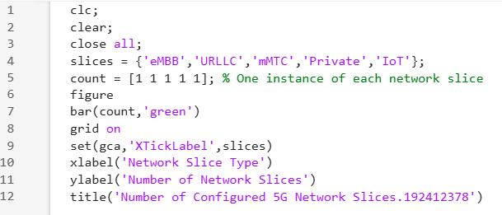
Expected Output
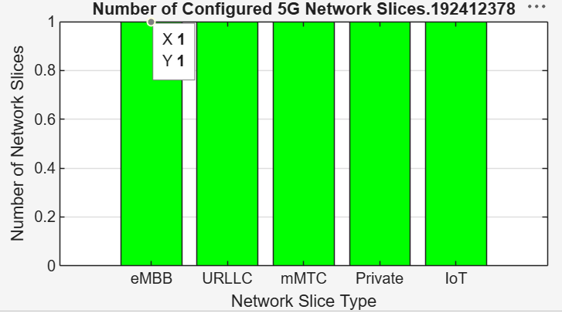
• Bar graph showing the number of configured network slices.
Objective – 2
Compare Slice Utilization (%)
Analyze the utilization percentage of different network slices using MATLAB. Compare the
resource usage of each slice to evaluate network efficiency.

MATLAB Code
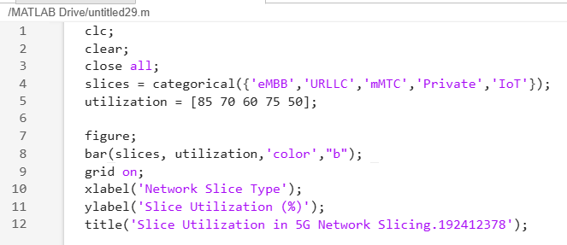
Expected Output
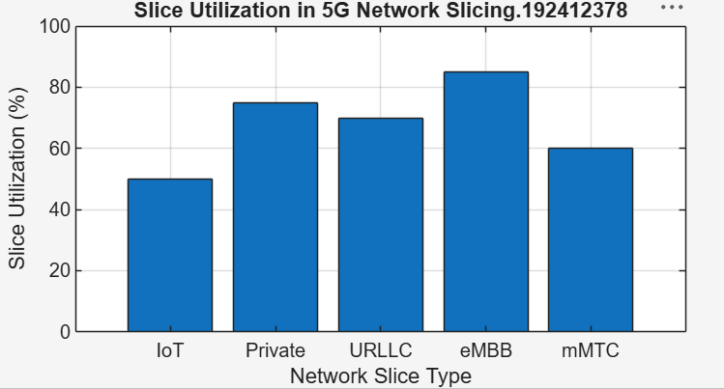
• Bar graph showing slice utilization (%).
Objective – 3
Analyze End-to-End Latency (ms)
Compare the end-to-end latency of different network slices using MATLAB. Observe how latency
varies depending on the service requirements of each slice.

MATLAB Code:
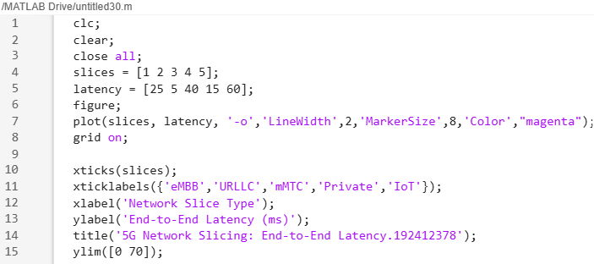
Expected Output
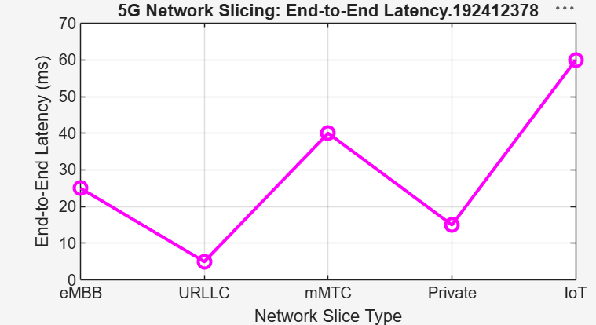
• Line graph showing end-to-end latency for different network slices.
Result
The MATLAB analysis successfully demonstrated the characteristics of a 5G Network
Slicing environment. The results showed that multiple network slices can coexist while
exhibiting different utilization levels and latency characteristics based on their intended
services.

